Created on: 1/28/05
Topic: Light and the Electromagnetic Spectrum

- Light is an electromagnetic wave
  - Wavelength – Distance from one crest/trough to another crest/trough
  - Frequency – Amount wave oscillates/cycles per second (hertz)
  - Wave amplitude – Vertical distance from the line of no disturbance to maximum disturbance
  - Wave height – Vertical distance from maximum disturbance above the line of no disturbance to maximum disturbance below the line of no disturbance
  - Wave height is double the wave amplitude
  - Speed (v) = frequency * wavelength
  - c = frequency * wavelength
- Frequency and wavelength are inversely proportional to one another
- Electromagnetic (light) spectrum
  - Radio (largest wavelength, shortest frequency, shortest energy, shortest temperature)
    - Longwave
    - Shortwave
      - AM
      - FM
      - TV
      - VHF
      - UHF
  - Micro
  - Infrared
    - Far (Long)
    - Near (Short)
  - Visible Light
    - Red (largest wavelength, shortest frequency, shortest energy, shortest temperature)
    - Orange
    - Yellow
    - Green
    - Blue
    - Indigo
    - Violet (largest frequency, largest energy, largest temperature, shortest wavelength)
  - Ultraviolet
    - Near (Long)
    - Far (Short)
  - X-rays
    - Soft (Long)
    - Hard (Short)
    - Gamma (largest frequency, largest energy, largest temperature, shortest wavelength)
- The higher the frequency, the higher the penetrating power
- Black body spectrum graph:
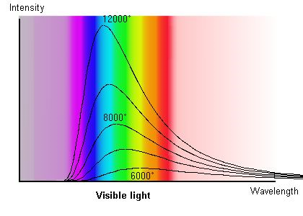

- Amplitude = brightness
- High amplitude = high brightness
- Low amplitude = low brightness
- Amplitude and wavelength are independent
- Sound is a wave
  - Travels at 300 meters/second
  - Speed of sound (v) = frequency * wavelength
  - Large amplitude = loud sound
  - Small amplitude = soft sound
  - Frequency of a sound wave is the pitch
  - High pitch = high frequency, small wavelength
  - low pitch = small frequency, high wavelength
  - Amplitude and frequency are independent
- The Doppler effect
  - Sound moving toward a detector = high frequency
  - Sound moving away from a detector = low frequency
  - Can be used for light waves!
    - Light moving toward a detector = Blue Shift
    - Light moving away from a detector = Red shift
  - You would have to move at the speed of light for the light to actually change color

